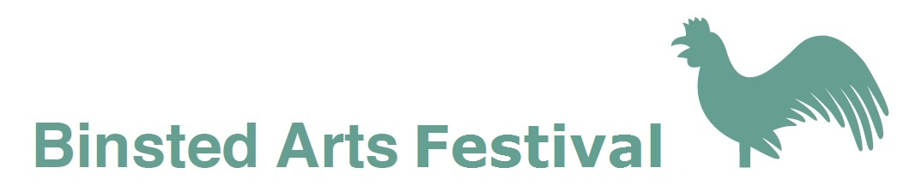

Poetry Competition

Judge: Jeremy Page

Jeremy Page is the author of seven collections of poems
and has edited The Frogmore Papers since 1983.

Original unpublished poems are invited on the theme:

Country

Prizes: £150, £100, £50

Poems, with entry forms and fees (cheques made out to Binsted Arts)
should be posted to:

Competition Secretary
Shirley Park, Yapton Lane,
Walberton, Arundel, BN18 0AN

to arrive by the closing date of Monday, April 9, 2018

Prizewinners will be invited to read their poems in Binsted Church (BN18 0LL)
during the poetry evening, one of the events in the 2018 Binsted Art Festival,
on Friday 8 June, 2017 at 7 pm

For full details of the Binsted Arts Festival visit
www.binsted.org/arts-festival

Binsted Arts Poetry Competition Entry Form 2018

Name...................................................................................

Address...............................................................................

……………………………………………………………………………

Postcode………………………………………………

Email...............................................................

Phone number.................................................

Title(s) of poems submitted

I enclose a cheque payable to Binsted Arts for £.........

Terms and conditions:

Entry fee: £5 for the first poem, £3.50 for subsequent poems

Send 2 copies of poems, each on a separate sheet, with entry form, to
Competition Secretary Shirley Park, Yapton Lane, Walberton, Arundel, BN18 0AN

No author names on poems - personal details to go on entry form.only

Poems must be the original work of the named author and must not have been previously published or won a prize in any competition. Poems being submitted to other competitions can be accepted subject to withdrawal if another prize is awarded before winners in this competition are notified of placings.

Poems must not exceed 40 lines, must be typed, single spaced, in Times New Roman 12 point.

The judge will read all entries and his decision is final. Copyright remains with the author. Winners and commended authors may be asked if their poems can be included on the Binsted Arts website and in a small anthology.

Further copies of this form can be downloaded from http://www.binsted.org/poetry-comp-18

